Jasmine Fulton
Argument Document
Professor Holloway
Feb. 17th, 2016
Exercise, Nutrition, and Wellness in Elementary Schools
Lack of Physical Education in Schools
Not only does healthy eating habits play a factor in this but also physical activity too. I think this problem begins in schools. They have started changing the meal options in school pertaining to a more healthy nutritious meal, but I also think they should improve the physical education as well. According to studies done, increasing recess physical activity has been the aim of several interventions, as this setting can provide numerous physical activity opportunities. However, it is unclear if these interventions are equally effective for all children, or if they only appeal to children who are already physically active. This study was conducted to explore the least physically active children’s “lived experiences” within four existential life worlds linked to physical activity during recess: space, body, time, and relations. (Pawlowski)
Childhood Obesity
There has been an epidemic of childhood obesity. I know it’s so much easier when you’re a full time working parent, whether you’re doing alone or not to just pick up some food from a fast food restaurant rather than cooking. Parents do play a role in this as well, the money they are spending on these fast food places could be money going towards home cooked meals. Also, parents aren’t educated on how serious childhood obesity is and the affects it has on children. So, the first step to preventing this would have some type of education awareness for parents. There are plenty of easy, healthy meals now a days. You can throw something in the crockpot before work and it will be ready by the time you’re off work, depending what it is you’re cooking. If kids see their parents developing healthy habits, they will follow suit. Even if you’re just walking around your neighborhood, or parking your car further in the parking lot, every little bit of some type of exercise helps. Childhood obesity affects 1 of every 6 kids in the United States, in part due to a lack of physical activity. Historically, elementary schools provided daily recess and regular gym class, which offered opportunities for physical activity during the school day. More recently, emphasis on academic achievement, coupled with budget cuts, have prompted many schools to cut back on both recess and gym class. Parents are virtually unanimous (94% agree) in their views about the importance of physical activity for elementary-school kids during the school day. However, on-third of parents think their kids do not get enough physical activity at school. Parents own weight is related to perceptions of the need for schools to help children be physically active. (See Fig. 1) 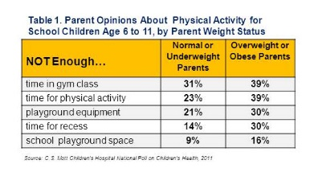
With regard to time for gym, playground equipment, time for recess and playground space, overweight and obese parents were more likely than other parents to say their kids did not have enough. (www.mottnpch.org)
Almost 7 in 10 parents say their child’s school does not provide daily physical education even though experts recommend 150 to 225 minutes per school week. NPR/Robert Wood Johnson Foundation/Harvard School of Public Health (HSPH) polled 1,368 parents of public school children in grades K-12 on a range of issues around education and health in their child’s school. One in four parents (25%) said their child’s school gives too little emphasis to physical education, compared with 1 in 7 who say the same thing about reading and writing (14%) or math (15%). In addition about 3 in 10 parents (28%) give a low grade (C,D or F) to their child’s school on providing enough time for physical education, while almost 7 in 10 parents (68%) report that their child’s school does not provide daily physical education classes, a recommendation included in CDC guidelines for schools. Just under 2 in 10 parents (18%) give a low grade to their child’s school on providing quality facilities for physical exercise, like playgrounds, ball fields, or basketball courts. Currently, less than half of youths meet the U.S Department of Health and Human Services Physical Activity Guidelines for Americans recommendation of at least 60 minutes of daily moderate-to-vigorous physical activity. This increases youth’s health risks and can jeopardize their well-being throughout their lives. Physical activity is also critical to children’s cognitive development and academic success. (www.hsph.harvard.edu)

One in three U.S kids is overweight or obese, but only six states- Alabama, Georgia, Mississippi, North Carolina, Illinois and Iowa adhere to standards from the National Association of Sports and Physical Education that school children participate in 150 minutes a week of physical education. And just three states Delaware, Virginia and Nebraska have 20 minutes of mandatory elementary school recess a day. In the proof of human nature department unless you’re required to do something, you probably won’t. Researchers found that 4% of schools in the six strong states or districts were nearly three times more likely to meet the 150 minute recommendation. In comparison, 17 states and 29% of school districts were considered weak. Twenty-four states and 67% of school districts had no P.E policies. When it comes to mandatory recess, five states were ranked weak, and 39 had no recess law. Just 19% of school districts required daily recess, 17% required some recess but less than 20 minutes a day and a full 64% had no recess policy at all. ( www.healthland.time.com)
Increasing Physical Activity
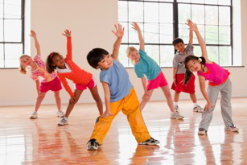
Increasing physical education in schools means increasing awareness in schools too. Physical activity is an important part in a child’s life. It also will help with the child obesity epidemic too. Ways in increasing physical activity in schools should involve more than just recess. Teachers should try and have learning activity that involves movement and not just sitting in the desk all day. I think they should revise the curriculum for every grade in elementary and try to accommodate the learning environment by adding exercise to it. It could something as little as getting up and walking around the classroom for a few minutes, as long as they are getting some type of movement in the classroom as well. I know some curriculum has “gym” but I don’t think that is enough, or just have recess is enough. With more of both parents working, not only are we relying on our teachers to help our children learn but also help they stay healthy and active. An increase in physical activity, we could possibly see behavior changes and a decrease in student problems.

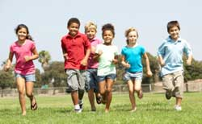

Works Cited

http://www.mottnpch.org/reports-surveys/gym-gone-not-forgotten-parents-want-more-physical-activity-school-kids

http://www.hsph.harvard.edu/news/press-releases/lack-of-physical-education-in-schools-concerns-parents/

www.healthland.time.com

Brittin, Jeri, et al. "Physical Activity Design Guidelines For School Architecture." Plos ONE 10.7 (2015): 1-30. Academic Search Premier. Web. 17 Feb. 2016.

Pawlowski, Charlotte Skau, et al. "Space, Body, Time And Relationship Experiences Of Recess Physical Activity: A Qualitative Case Study Among The Least Physical Active Schoolchildren." BMC Public Health 16.(2016): 1-12. Academic Search Premier. Web. 17 Feb. 2016.

